History-
As historians we will look at the history of toys and recognise the difference between the past and the present in our own lives. We will be able to ask and answer simple questions about the past using parts of the stories and other sources to show our knowledge of when certain toys were invented. We will develop our understanding of some of the ways in which we find out about the past and identify different ways it’s represented. We will record on a time line when well-known toys were invented (first Teddy bear, snakes and ladders etc.)

Literacy
In our writing journeys we will study:
- Descriptive writing ,instructions for our board game, letter writing, character feelings, recounts (Beaney trip) and story writing
Key Texts we will study:
Toys in Space, Lost in the toy museum, That Rabbit belongs to Emily Brown, Dogger by Shirley Hughes, The Gruffalo, The Gruffalo’s child and other texts by Julia Donaldson.

Geography
As geographers we will learn about the UK, which countries make up the UK and the national flag. We will explore the capital cities and understand that the UK is an island. We will make our own maps of UK with different media. We will explore the weather and use key vocabulary to describe some human and physical features. We will explore the origins of toys and locate them on a world map. We will also explore simple compass directions (NSEW).

Art and Design
As artists we will develop our observational drawing skills. We will bring in our favourite toy to sketch and then using the critique process make improvements. We will experiment with different pencil grades exploring different thickness of lines as well as dark and light tones. We will create different pictures using pastels and paint.
As designers we will take part in a toy workshop and design, make and evaluate our own wooden toy. We will use a range of tools and materials. We will design, make and play our own board game.
As designers we will make a pop-up book. We will draw upon our own experience to help generate and suggest ideas and explain what they are going to do. We will model our ideas in card and paper and develop our design, applying ideas from research. We will, with help, measure, mark, cut out and shape materials we use. We will evaluate our book and identify and possible changes needed.

Science- Animals including humans and seasonal change
As scientist we will:
- Identify and name a variety of common animals including amphibians, fish, reptiles, birds and mammals
- Identify and name a variety of common animals that are carnivores, herbivores and omnivores
- Observe weather across four seasons (focus on Autumn)
- Observe and describe weather and day length associated with the four seasons

Year 1
Term 1 & 2
What makes me a toy expert?
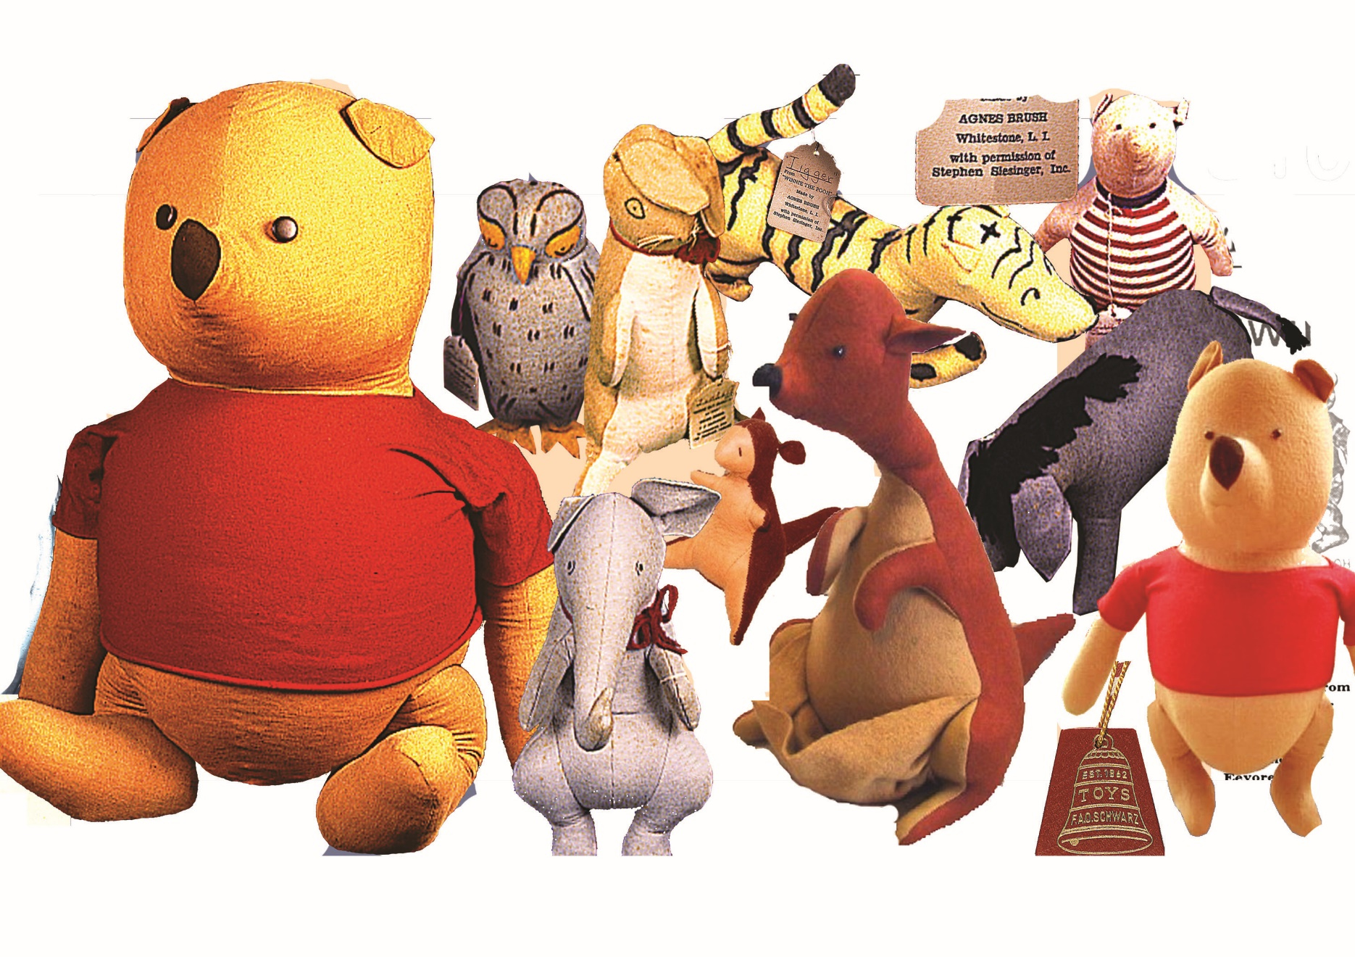

Computing- Getting started/ Beebots programming
We will recognise common uses of IT. We will learn how to log on and off safely and save our work. We will develop our skills with an online paint tool. We will learn to locate where keys are on a keyboard and develop our basis mouse skills. We will explore how hardware works. We will use beebots to navigate an area and construct simple instructions.

Enrichment: Victorian toy workshop, parents invited in to play board games, nativity at Christmas.

Modern Language- Spanish
We will listen attentively to spoken language and show understanding by joining in and responding.

PSHE
We will reflect on the choices we make and how they affect our own and others’ hearts.

RE- Christianity
Key Question: Does God want Christians to look after the world?
What gifts might Christians in my town have given Jesus if he had been born here rather than in Bethlehem?

PE- Dance/OAA
As dancers we will copy and explore basic movements and body patterns. We will link movements to sounds and music and remember simple movements and dance steps.
During OAA we will begin to develop accuracy and control. We will identify movements and skills which are effective.

Music: Pulse/ Rhythm -My Favourite things
We will learn to identify the difference between the pulse and rhythm of a song and consolidate our understanding of these concepts through listening and performing activities.

