RE- Christianity
Key Questions
- Was it always easy for Jesus to show friendship?
- Why was Jesus welcomed like a king or celebrity by the crowds on Palm Sunday?
PSHE
To know what a friend is and know some ways to cope with friendship problems. To recognise when people are being unkind and unfair and how to respond.

Enrichment: Captain Raggbybeard Pirate day

Music: Under The Sea Musical Vocabulary
We will learn about different types of music vocabulary. We will explore pulse and tempo as well as dynamics, timbre, texture and structure.

Art and DT- Artist Henri Matisse

As artists we will explore the work of Henri Matisse. We will ask sensible questions and say what we like about his work. We will create a piece of artwork in response to his work. We will use paint to create secondary colours, mix, match and predict outcomes and we will create tints by adding white and tones by adding black. We will mix brown for our pirate ship painting.

To link with our science, in DT we will design and make pirate ships applying all our knowledge of properties of materials.

Modern Language- Spanish
We will learn vocabulary linked to ‘The circus’ and ‘Minibeasts’

PE- Yoga, Throwing and catching, Kurling, Football.
In yoga we will copy and explore basic movements and body patterns. In team games we will develop our hand eye coordination and will develop our ability to send and receive a ball with basic control. We will participate in simple games.

Computing
We will learn how to keep ourselves safe online. We will explore the meaning of the phrase digital footprint.

Geography
As geographers we will name and locate the 7 continents of the world and 5 oceans (make links with pirates and the seas and countries they went to). We will use simple field work and observational skills to study the geography of the village.

Science- Materials/Seasonal change
As scientist we will:
- Distinguish between an object and the material from which it is made
- Identify and name a variety of everyday materials, including wood, plastic, glass, metal, water and rock.
- Describe the simple physical properties of a variety of everyday materials
- Compare and group together a variety of everyday materials on the basis of their simple properties
- We will name the current season and discuss the weather.

History
As historians we compare versions of a past event (pirates) we will compare pictures, photographs of these people and events and discuss their reliability. We will identify similarities and differences between ways of life in different periods. We will study the lives of significant others looking at famous pirates (Edward Teach Blackbeard, Anne Bonny) We will look at the explorer Christopher Columbus.

Literacy
In our writing journeys we will study:
- Character and setting descriptions, character feelings, poetry, recounts, fact files and story writing.
- Key texts we will study:
The pirates next door Pirate mums
Sunk Mrs Pirate
Billy and the Pirates Non-fiction texts.
Year 1
Term 3 and 4
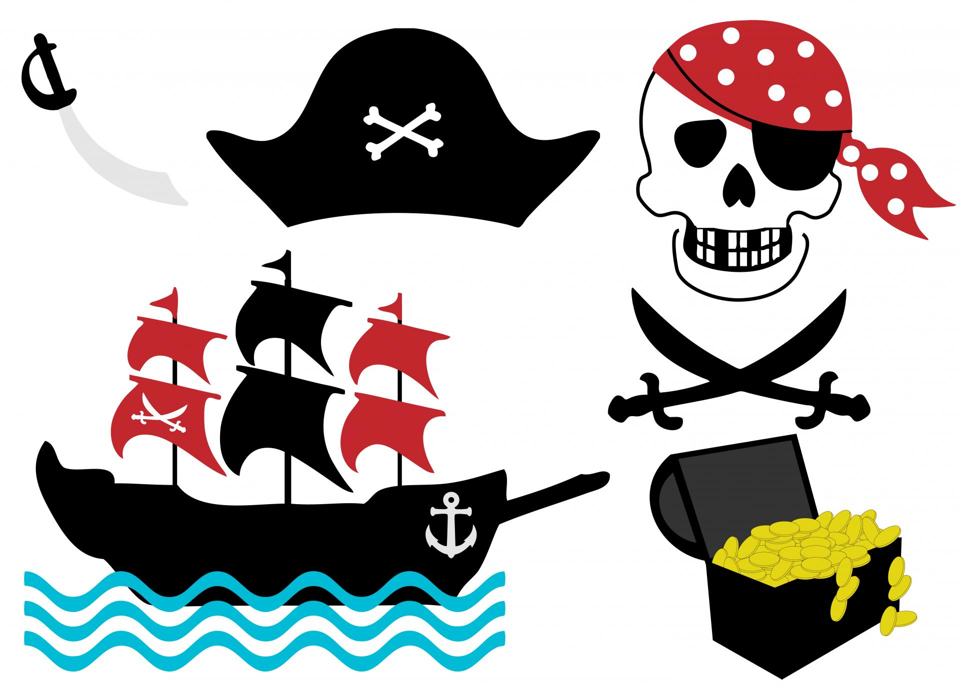
Is a pirate’s life for me?

[Grab your reader’s attention with a great quote from the document or use this space to emphasize a key point. To place this text box anywhere on the page, just drag it.]
[Grab your reader’s attention with a great quote from the document or use this space to emphasize a key point. To place this text box anywhere on the page, just drag it.]

