Enrichment Parents will be invited in to watch and support their children in a science and a P.E lessons – dates to be confirmed

Modern Language- Spanish
The children will begin learning key Spanish greetings as well as practising how to ask questions.
Music – blues We will learn about the origins of blues music and how it affected modern music. We will learn about singing in tune and using expression to convey meaning as well as understanding different blues notes.

Computing – Mars Rover We will explore inputs and outputs as well as binary numbers to understand how the Mars Rover transmits and receives data and how scientists are able to control it to explore another planet.

PHSE We will reflect on how we protect our own and other’s hearts. We will think about the choices we make and who we can turn to for help.

Art and DT
Art – As artists we will consider the works of David Hardy and Peter Thorpe. We will use their works as inspiration to develop our sketching, shading and painting skills to create our own pieces of work in these differing styles.
DT –We will design, construct and evaluate our own moon buggy using measuring, joining and sawing skills to produce a final product

Literacy Key texts we will study:
- The Astronaut’s Apprentice - Philip Threadneedle
- The Astronaut’s Apprentice – City of Meteors - Philip Threadneedle

History As historians we will consider how travel to space has changed over time, the space race between USA and USSR and the impact this has had on Britain and the wider world.

Geography We will learn about France. We will locate countries that border France, look at the seas around the coastline, research French culture and main cities and explore the climate across the country.
We will look at how the Earth can be divided – longitude, latitude, equator, hemispheres, continents etc

Year 5
Term 1 and 2
What would it feel like to be in space?
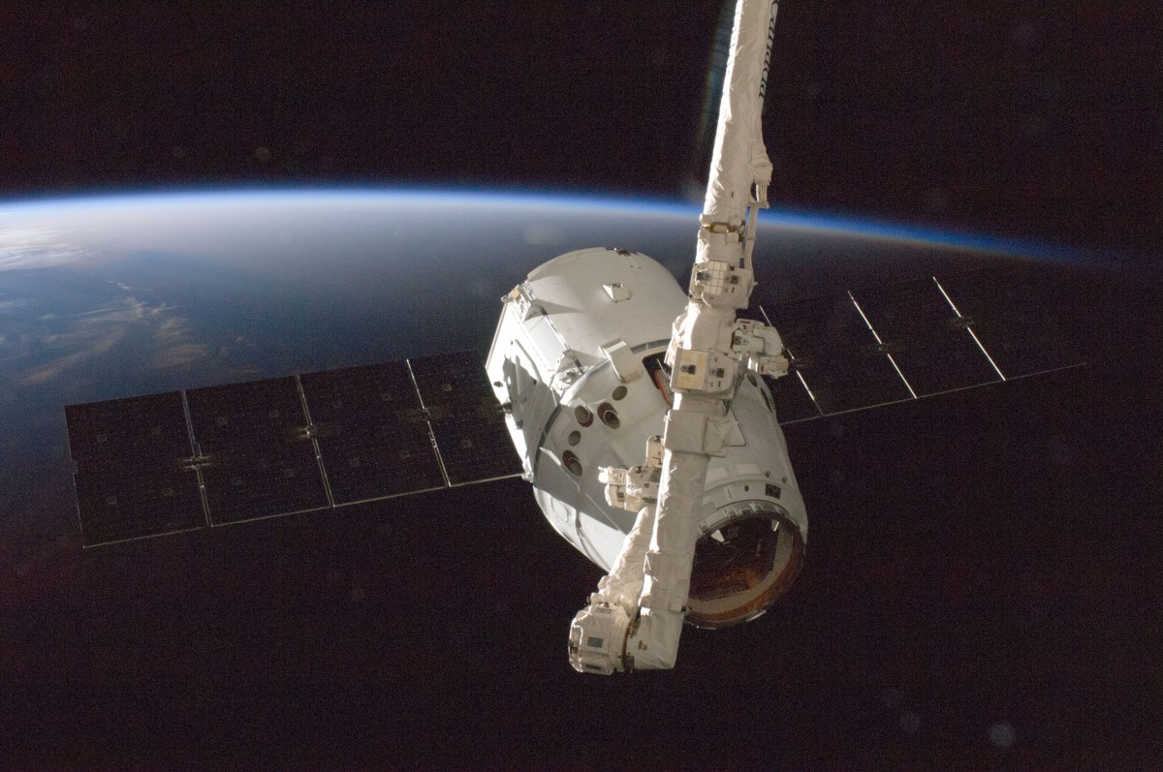

Science – Earth & Space / Forces
As scientists we will:
- Describe the movement of the Earth and other planets
- Describe the movement of the Moon relative to the Earth
- Use the idea of the Earth’s rotation to explain day and night and the apparent movement of the Sun across the sky
- Explain that unsupported objects fall towards the Earth because of the force of gravity acting between the Earth and the falling object
- Identify the effects of air resistance, water resistance and friction that act between moving surfaces

RE – Sikhism & Christianity
Theme: Belief into action & Christmas
Key Questions: How far would a Sikh go for his/her religion? Is the Christmas story true?

PE – OAA, dance, Gymnastics and fitness circuits
In dance, we will learn to demonstrate strong movements throughout a dance performance whilst combineing flexibility, technique and movements to create a fluent sequence.
In OAA, we will use and interpret simple maps as well as applying strategies to solve problems with peers.
In gymnastics, we will apply previously learnt skills to create sequences whilst developing precision and control when moving.
In fitness circuits, we will learn about the effects of exercise on the body, understand the need to warm up and discuss the importance of a healthy lifestyle.

