Modern Language - Spanish
We will widen our knowledge of the language by learning key phonics skills to help pronounce words which relate to different foods.

Literacy
In our writing journeys we will study and write:
- Narrative
- Scene Setting and Character Description
- Composition of a story
- Non-fiction factual writing
- Poetry
Key texts we will study are:
- The Railway Children by E. Nesbit
- Polar Express by Chris Van Allsburg
- From A Railway Carriage by Robert Louis Stevenson.
- Non-fiction texts relating to George Stephenson.

Computing – Collaborative learning and coding with Scratch
We will be learning how to work collaboratively using Microsoft Office tools in a responsible and considerate way as well as looking at a range of collaborative tools when using Excel and online. We shall be learning the basics of programming in Scratch by creating a simple script, using decomposition and understanding what variables are.
Geography
As geographers we will locate the world’s countries, using maps to focus on Europe (including Russia). We will identify the position and significance of the Greenwich Meridian time zones and the significance of the Equator, the Northern and Southern hemispheres and the tropics of Cancer and Capricorn. We will use maps to discover the route taken by the Orient Express and look at the impact of cars, planes and trains to describe and understand key aspects of human geography.

RE – Judaism and Christianity
Key Questions:
- How special is the relationship Jews have with God?
- What is the most significant part of the nativity story for Christians today?
PSHE- Reflect on how we care for our own and other’s hearts by showing love and kindness. We will learn to celebrate our strengths and achievements.

Year 4
Terms 1 and 2
How has transport changed the world?
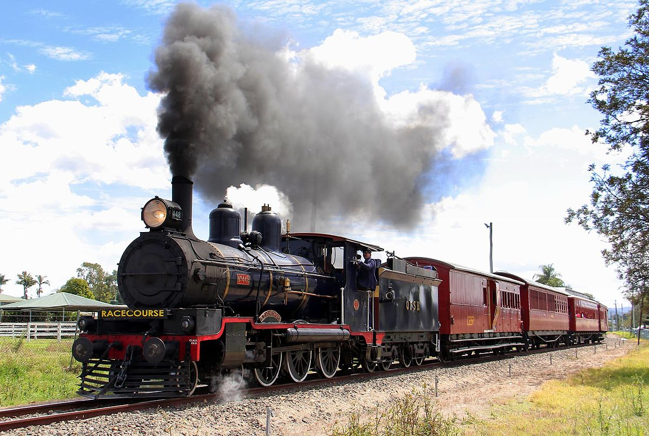

PE: OAA, Dance and Games
In games we will develop our confidence in using ball skills in a variety of ways and link these together. We will use skills with coordination, control and fluency and take part in competitive games with a strong understanding of tactics and composition. We will apply basic skills for attacking and defending. As dancers we will respond to stimuli with increasing precision and control in order to create longer dance sequences. We will begin to vary our dynamic movement and demonstrate rhythm and spatial awareness. We will evaluate our work and modify parts of it. As orienteers, we will use maps and clues to navigate the school grounds.

Enrichment
We will visit one of the local steam railways or museums.
Music - Body and tuned percussion + Recorder
As musicians we will identify the structure of a piece of music by recognising the use and development of motifs, gradual dynamic and tempo changes in music. We will identify scaled dynamics (crescendo/decrescendo) within a piece of music and use musical vocabulary when discussing improvements to our own and others’ work. We will learn to play and perform the recorder.

Art and DT As artists we will review/ evaluate our own and other’s work. We will adapt and improve our own work through critique from our peers. We will use our sketch books to record our observations of modes of transportation as well as to draw ideas for of our own. We will compare the railway paintings of Monet and Turner and use these to inspire our own transport themed paintings and drawings. We will explore water colours and collage linked to trains and use this to inform our own collage piece.
As designers we will link with our topic of transport and study bridges designed by Brunel and Eiffel. We will select the appropriate tools and techniques to make a bridge to support our vehicle and evaluate it against our original design and make improvements before displaying it. We will also revisit Elijah McCoy and learn about how his inventions improved the steam engine and our lives.

Science - Electricity and States of Matter
As scientists we will:
- Identify common appliances that run on electricity
- Electricity safety.
- Construct a simple series electrical circuit, identifying and naming its basic parts, including cells, wires, bulbs, switches and buzzers.
- Recognise some common conductors and insulators, and associate metals with being good conductors.
- Explore solids, liquids and gases, classifying objects and identifying their properties. We will work scientifically and collaboratively to investigate the weight of a gas. We will explore in-depth how water changes state, exploring melting, freezing, condensing as well as a particular focus on evaporation.

History - A study of an aspect or theme in British History that extends pupils chronological knowledge beyond 1066

As historians, we will study the introduction of the railways in Britain to understand them as a significant turning point in British history, including the impact of the industrial revolution. We will learn about how the past affects our lives today and recognise the differences between the past and present Britain.

