Computing - Online Safety and Computational thinking
We will learn how to search over multiple platforms online and be aware of the difference between fact, opinion and belief and recognise these online. We will also learn how to understand the need to be thoughtful when working on a collaborative document when creating a survey with a range of different question types that will provide different types of answers.

Enrichment – Musical instrument making workshop and musical composition competition.

Music – ENO Finish This Project
The children will be embracing their inner composer by listening, playing and performing in solo and ensemble contexts. Through teamwork and collaboration, the children will develop an understanding of musical notation which will support them in composing their own piece of music.

RE – Judaism and Christianity
Theme – Passover and Easter
Key Questions
- How important is it for Jewish people to do what God asks them to do?
- Is forgiveness always possible for Christians?

PE – Yoga, Cricket, Hockey and Rugby
In games we will develop our confidence in using ball skills in a variety of ways and link these together. We will use skills with coordination, control and fluency and take part in competitive games with a strong understanding of tactics and composition. We will apply basic skills for attacking and defending. In yoga, we will link different skills with control, technique, co-ordination and fluency. We will begin to improve and refine our performances.

Geography
As geographers we will build upon existing knowledge of countries in South America and focus on Paraguay linking with our text Ada’s Violin. We will describe and understand key aspects of physical and human geography, land use and make comparisons with Europe.

PSHE - We will learn how to identify how those around us might be feeling. We will think about how we can work together to achieve shared goals and show kindness. We will think about friendships and also learn about personal boundaries including online. We will develop our understanding of how to use technology responsibly.

Modern Language- Spanish
We will further develop our linguistic skills by extending their knowledge and skills to present themselves both orally and in written form in Spanish and continue to grasp basic grammar concepts (gender, determiners, and plurality).

Year 4
Term 3 and 4
Where do sounds come from?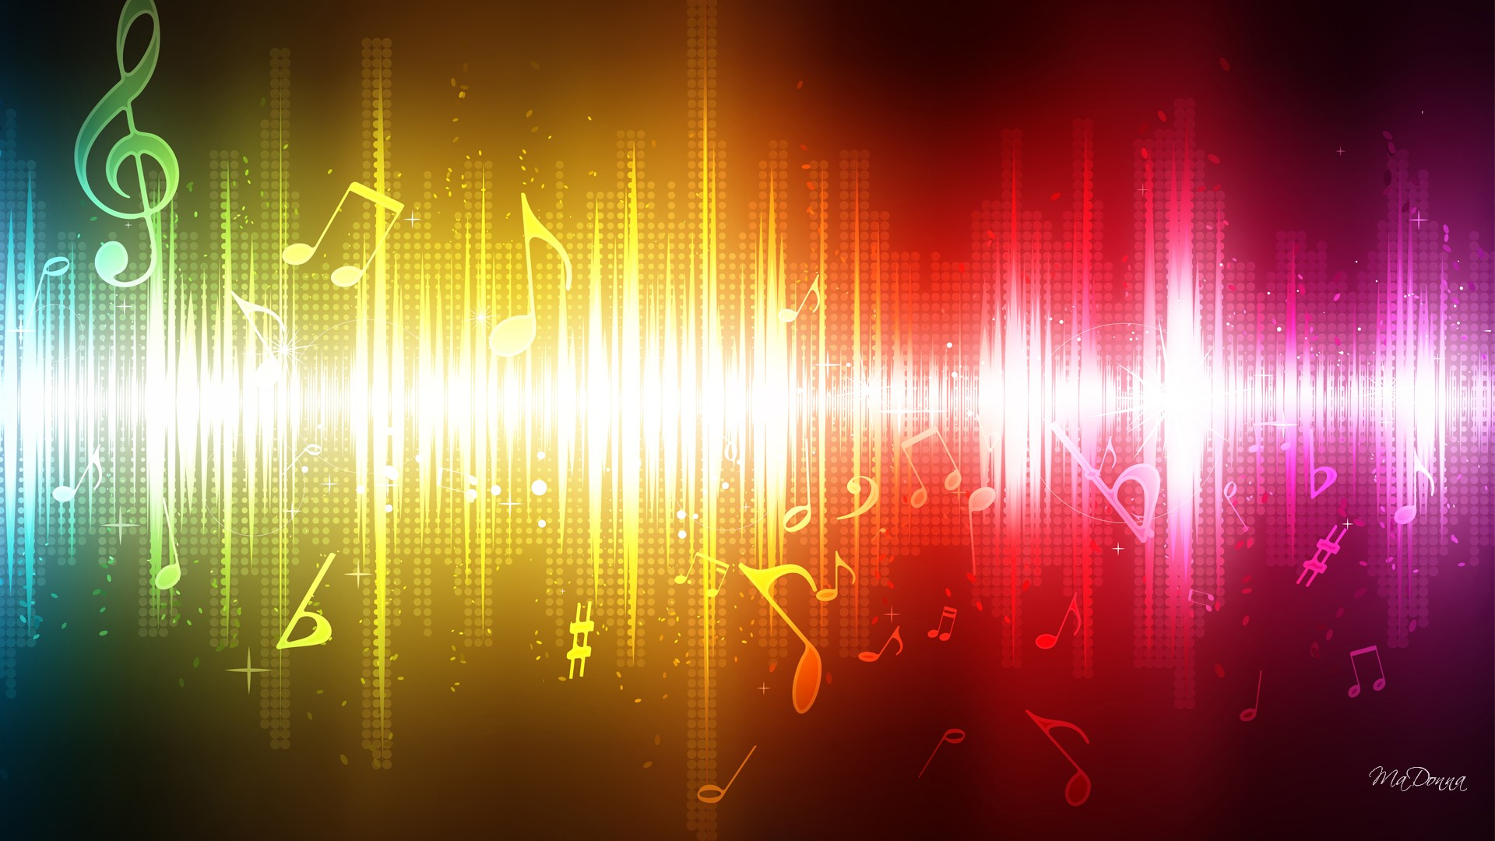

Art and DT
As artists we will study the work of Rothko to take inspiration independently from other artists or cultures. We will begin to understand his viewpoint and understand what he is trying to express. In our own paintings we can express mood and feeling. We will review, evaluate own and other’s work and adapt and improve own work through the critique process.

As designers we will design, make and evaluate our own musical instruments made from recycled materials that play notes of differing pitch. We will select appropriate tools and techniques for making our instruments. We will learn to perform as an orchestra using our instruments performing to an audience.
Science - Sound
As scientist we will;
- Identify how sounds are made, associating some of them with something vibrating
- Recognise how sounds travel through a medium to the ear
- Find patterns between pitch and sound and features of the object that produced it
- Find patterns between the volumes of sound and features of the object that produce it
- Recognise that sounds get fainter as the distance from the sound source increases.

Literacy
In our writing journeys we will study and write:
- Poetry – writing and performing
- Report writing – newspaper report
- non-chronological
- Recounts – diary writing
- A balanced argument – persuasive letter
Key texts we will study are:
- Ada’s Violin by Susan Hood
- Drum Dream Girl by Margarita Engle
- The Sound Collector by Roger McGough

