Modern Language - Spanish
We will further develop our linguistic skills by learning a selection of the key phonemes to facilitate accurate and authentic pronunciation as part of their language learning experience. We will also study the unit on ‘I am learning Spanish’ to have the knowledge and skills to be able to introduce themselves, say how they feel and have a wider appreciation for the country/ countries the foreign language is spoken.

Computing: Systems and Networks
In computing we will learn about computer networks to understand how digital devices connect and communicate. We will explore key vocabulary such as "network," "router," and "internet" to support comprehension of how data travels between devices. We will also learn about wired and wireless connections and outlines the advantages and challenges of networked systems.

Music
As musicians we will study a series of Instrumental lessons. In Term 1, we will look at whole class instrumental lessons on tuned percussion. We will look at music from South Africa that develops pupils’ rhythmic, singing and notation skills.
In term 2 we will learn about the history and features of Calypso music, performing a calypso style song with voices and tuned percussion in multiple parts and playing from staff notation.

Art and DT

We will look at ’Chiaroscuro’ and the artists that uses this technique in their paintings (Leonardo Da Vinci and Caravaggio- The Calling of St Matthew )We will then develop our shading skills to show light and tone in our pictures. We will explore cave paintings and use the environment to make our own brushes and paint to recreate our own inspired pieces of art.
As designers we will investigate a range of different types of lamps including candle, oil and electric. We will design, make and evaluate our own lamp.

Rowan Class
Term 1 and 2
What would it be like to live in a world of darkness?
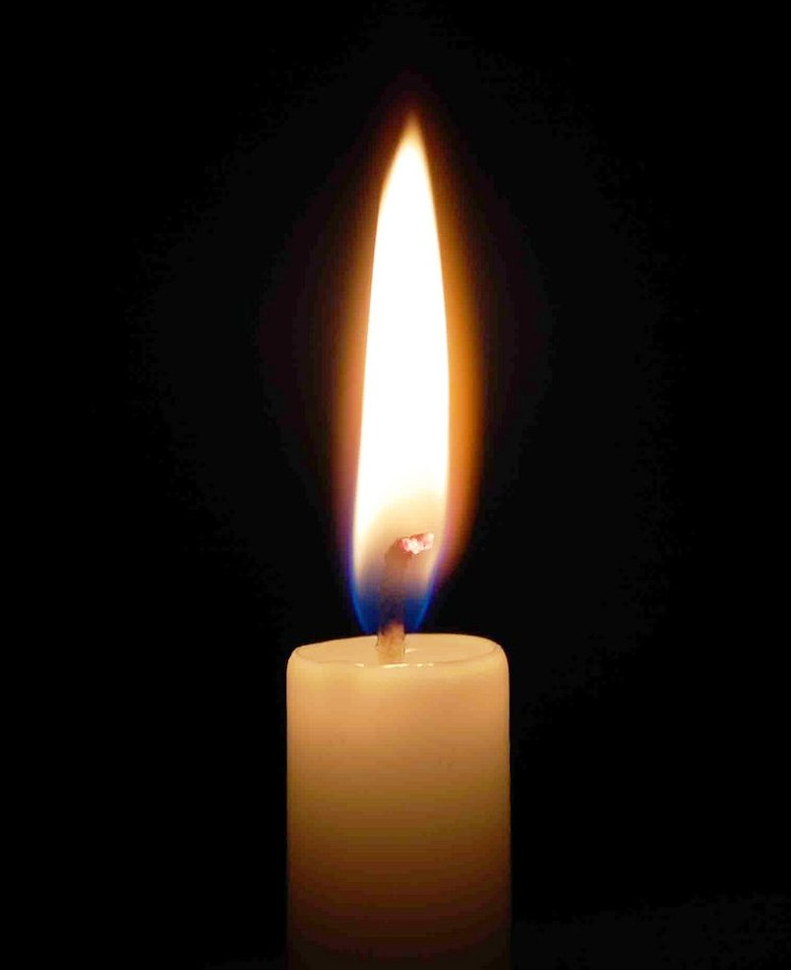

RE – Hinduism/ Christianity
Key Questions: Would celebrating Diwali at home & in the community bring a feeling of belonging to a Hindu child?
Has Christmas lost its true meaning?

PSHE-
Reflect on how we care for our own and other’s hearts.
We will learn to accept the encouragement given to us by others.

Enrichment -
Kent Life Stone Age Day.

PE – OAA and Dance
In OAA we will develop further our listening skills and by working closely with a partner. We will begin to think through activities and problem solve as well as being able to recognise what went well and why.
As dancers, we will continue to translate our ideas from stimuli into movement, improvising with a partner to create a simple dance, comparing and adapting our movements to create a longer sequence.

History
As historians, we will look at changes in Britain from the Stone Age to the Iron Age. (Including Late Neolithic hunter-gatherers and early farmers e.g., Skara Brae, Bronze Age religion, technology and travel. Iron Age Hill forts and tribal kingdoms, farming, art and culture). We will compare life, traditions, and the changes over time. We will compare with other periods of history we have studied.
Science- Light/Rocks
As scientist we will;
- recognise that we need light in order to see things and that dark is the absence of light
- notice that light is reflected from surfaces
- recognise that light from the sun can be dangerous and that there are ways to protect our eyes
- recognise that shadows are formed when the light from a light source is blocked by an opaque object
- find patterns in the way that the size of shadows change.
- Compare and group together different kinds of rocks on the basis of their appearance and simple physical properties
- Describe in simple terms how fossils are formed when things that have lived are trapped within rock
- Recognise that soils are made from rocks and organic matter.

Geography
As geographers we will identify the position and significance of the equator, the Northern and Southern hemispheres. We will use maps, atlases, globes and digital/computer mapping (Google Earth) We will locate countries that furthest and closest to the equator and compare their environments linking with our topic on light and dark. We will study Svalbard in Norway and make comparisons with countries studied (Europe/ UK).

build

Literacy
In our writing journeys we will study:
- Narrative
- Letter writing and diary writing
- Character descriptions
- Non chorological report
Key text we will study are:
The Dark by Lemony Snicket (Term 1)
Stoneage Boy by Satoshi Kitamura (Term 2)

