Year 6
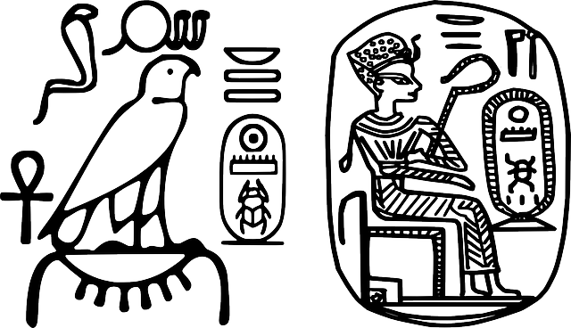
Term 3 and 4
Were the Ancient Egyptians achievers?

Computing – Intro to Python (Kapow)
In Term 3, we will be learning about online safety. In Term 4,we will build on our knowledge of coding by learning about the text-based programming language Python. We will learn that websites can be altered by exploring the code beneath the site. We will design, write and debug programs that accomplish specific goals. In E safety week we will learn more about the impact and consequences of sharing information online; exploring how to develop a positive online reputation along with capturing evidence techniques and methods to combat online bullying.
Modern Language- Spanish
As linguists we will further develop our proficiency in Spanish by studying the units In Spanish, we will be learning about ‘the clothes’ & ‘at school.’

Literacy
In our writing journeys we will study:
- Biographies/autobiographies
- Balanced arguments
- Narrative with flashbacks
- Leaflets as part of history and geography
Class readers:
- Secrets of a Sun King by Emma Carroll
- In Search of the Boy King by Anthony Masters

Enrichment
We will take part in an Egyptian Day workshop.

Music As musicians we will develop our knowledge about the importance of music and dance to Ancient Egyptian culture. We will learn about modern Egyptian music. We will continue to learn to play the ukulele.

History
As historians we will learn about the achievements of the earliest civilisations. We will gain an overview of where and when the first civilisations appeared. We will complete an in depth study of Ancient Egypt.

Geography
As geographers we will use a variety of maps, atlases, globes and digital mapping to locate Egypt and identify human and physical characteristics, key topographical features (including the Nile), land-use patterns and settlements. We will develop our understanding of how these have changed over time. We will use our geographical skills and understanding to (particularly our understanding of scales) to help us to compare Egypt to the UK, identifying similarities and differences.

PE – Games & fitness

In games we will vary our skills, actions and ideas and link these in ways that suit the games activity. We will take part in competitive games (cricket/rugby & hockey) with a strong understanding of tactics and composition. We will apply our knowledge of skills for passing, dribbling and shooting, as well as defending. We will also begin to learn Yoga skills (flexibility and movement).

RE – Christianity. Key Questions:
Is anything ever eternal?
Is Christianity still a strong religion 2000 years after Jesus was on Earth?
PHSE - We will think about our similarities and differences, how we can be a good friend and about the dangers of social media. We will develop strategies to resolve conflict and disputes. We will think about how to build trust between friends.

Science- Electricity & Animals including humans As scientists we will:
Associate the brightness of a lamp or the volume of a buzzer with the number and voltage of cells used in the circuit.
• Compare and give reasons for variations in how components function, including the brightness of bulbs, the loudness of
buzzers and the on/off position of switches.
• Use recognised symbols when representing a simple circuit in a diagram.

-identify and name the main parts of the human circulatory system and describe the functions of the heart, blood vessels
and blood
• recognise the impact of diet, exercise, drugs and lifestyle on the ways their bodies function
• describe the ways in which nutrients and water are transported within animals including humans.

Art and DT
Art – As artists we will learn about the techniques used by Ancient Egyptians to create wall paintings and carvings, printings, sculpture, models, jewellery and Canopic jars. We will link this to our understanding of historical sources. We will use the techniques we have learnt to create our own work and will use our critique skills to improve our Canopic jars. DT – As designers we will learn about the inventor David Missell (torch). We will use our scientific knowledge to design, make and evaluate our own torch.

