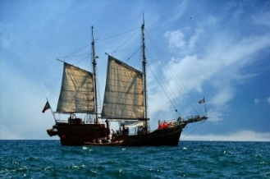

Curriculum Newsletter Term 3
Year 1
Unit: Is a pirate’s life for me?
Miss Gibbons and Mrs Braund
P.E is on Monday (Yoga) and Wednesday (Throwing and catching)

Wider Curriculum:
In art, we will be learning about Henri Matisse. We will learn about his famous collage called ‘The Snail’ and create our own. We will also learn about his seascape collages and create our own sea themed collage by cutting and tearing different paper. In Geography, we will be learning about the continents and oceans. We will map out the journeys that pirates took. In history, we will be learning about famous pirates from the past. We will learn about the parts of the pirate ship, the food pirates ate, what they did and where they sailed. We will also be learning about the explorer Christopher Columbus.

Literacy:
This term we will be reading ‘The Pirates next door’, ‘Sunk’ and ‘Billy and the Pirates’. We will focus on writing sentences using the correct punctuation and our phonics knowledge. We will write setting and character descriptions, simple letters, messages in a bottle, diary entries and stories.
Maths:
We will be learning about numbers to 20. We will represent numbers, find one more/less, order and compare numbers. We will also add and subtract within 20 using practical resources to help us.

R.E: Christianity
We will consider and answer the question, ‘Was it always easy for Jesus to show friendship?’ To answer this, we will learn about some of the stories in the Bible.
Computing
We will be learning how to stay safe online.
Music
Our music topic for this term is called ‘Under the Sea’. We will be learning musical vocabulary such as tempo and pulse.
PSHE (Heartsmart):
We will learn about the importance of thinking about others as well as ourselves.

Helping at home:
Please continue to read daily and practise reading and spelling the words which are stapled into the yellow book each week. Please also remember that spellings can be practised on Emile.

