Curriculum Newsletter Spring Term 1
Helping at home: Read as often as possible and record each time in the reading record books. This is so we can keep track of when and what they are reading.
Maths- Focus on the 2, 5 and 10 times tables as well as number bonds to 10 and 20. Please also use times table rock stars and Emile for spellings. The log in information is in the reading record books.
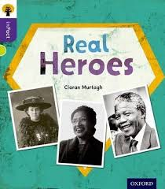
Year 2
Unit: Are heroes worldwide?
Mrs Piper, Miss Curzon and Miss Jordan
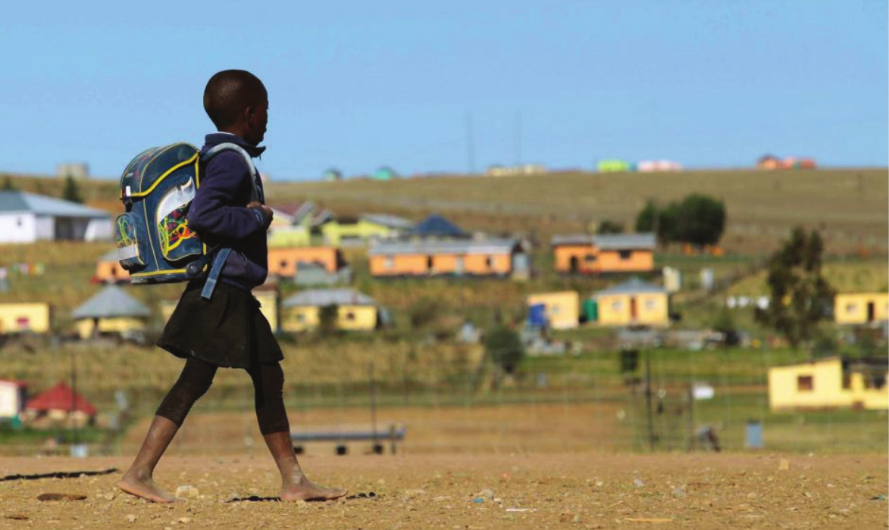
Literacy: Year 2 will look at a range of genres this term including writing for different purposes, letter writing, non-fiction writing relating to African traditions and poetry.
The key texts we will be looking at are – Lila and the Secret of the Rain and Meerkat Mail. We will also look at Non Fiction books about Nelson Mandela and Africa.
Computing: We will be looking at on line safety this term. We will look at what happens to information posted online; how to keep things private online; who we should ask before sharing online; describing different ways to ask for, give and deny permission online.

Wider Curriculum: In Geography we will develop our understanding of geographical similarities and differences through studying the human and physical geography of Wingham and a village in Africa. In DT we will explore how traditional African musical instruments are made. We will design and make our own instruments. As artists we will explore the textiles, beadwork, pots and masks that are important aspects of African culture. We will think about pattern and use this on our African instrument that we make.

P.E. is on a Wednesday and Thursday.
Forest School is on a Friday (weather permitting)
Enrichment: We hope to be having a zoom session with someone in Africa to show us the African bush. We are hoping to have some visitors from Africa to tell us about life there.
Global Citizenship week

R.E: Passover
We will be thinking about the questions - How important is it for Jewish people to do what God asks them to do?

PSHE: We will continue following the Heartsmart programme and will be developing our awareness of our surroundings and others around us.

Numeracy: The children will be looking at money for the first few weeks. We will then be working on multiplication and division.

