Curriculum Newsletter Autumn Term 3
English
This term, Maple class will write from different perspectives when writing a diary entry. They will focus on using emotive language as well as ensuring sentences are grammatically correct. They will also write an explanation text linking their knowledge of everyday materials and explaining which are the best to use for specific tasks. They will use formal language and write in certain tenses within their writing.
Helping at home: Read as often as possible and record each time in the green reading record. This is so we can keep track of when and what they are reading. Times tables! Children should know all the times tables up to 12 x 12. Practise, practise, practise!

Home learning will be sent home on a Friday. This will usually be a piece of maths that links to the work learnt during the week. Extra home learning will be available to those children wishing to challenge themselves.
Year 5
Unit: How would you protect your family?
Mr Pile and Miss Frost
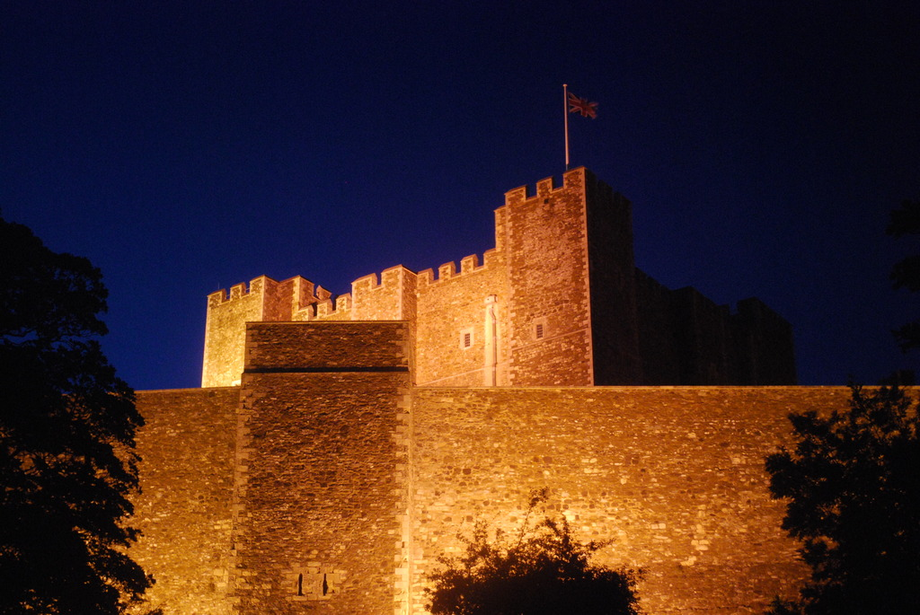

Spanish: Do you have a pet?
In this unit pupils will learn 10 familiar animals and be introduced to the 1st person singular high frequency verb ‘I am’.
Enrichment:
- Outdoor learning linked to Dover castle
- Young Voices singing practice.
P.E is on Monday (yoga) and Tuesday (cricket)
R.E: Are Sikh stories important today? Maple class will read and discuss Sikh stories from the past and talk about the moral of these stories.

Wider Curriculum: This topic will focus on the history and change of Dover castle from 1066 up to the present day. They will learn about its defences and how it was used during medieval times. In DT, the children will learn different sewing techniques before creating their own work
Computing – Looping and Online Safety
We will learn how to perform a looped body percussion rhythm as well as keeping in time. We will also create our own loops using computers to support our learning. Children will learn about using trusted websites and discussing the use of social media.

Maths: The children will work on using different methods to calculate multiplication questions (short, grid and long multiplication). They will also move back to working with fractions and will learn to find fractions of amounts and multiply fractions.

