Curriculum Newsletter Spring Term 1
Literacy:

In our writing journeys we will study:
· Biographies/autobiographies
· Balanced arguments
In class we will be reading Secrets of a Sun King by Emma Carroll.
Year 6
Unit: Were the Ancient Egyptians achievers?
Mr Perry, Miss Burke, Mrs Baldwin & Mrs Sweeney
Helping at home:
Spelling homework will be sent out on a Monday afternoon and maths homework will be sent out on Friday afternoon. Please ensure that your child is reading for 15/20 minutes every day and recording this in their reading record. Continued practise of all 12x12 times tables will help to support their mathematical understanding.

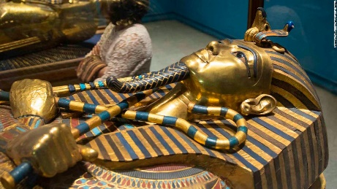
Science: We will be studying electricity and electrical circuits. This will include the study of influential scientists, such as Nikola Tesla and Thomas Edison.
Wider Curriculum: In History and Geography, we will be studying Egypt and the Ancient Egyptians. We will use atlases and online maps to study the geography of the country and the importance of the River Nile. We will learn about the beliefs and achievements of the Ancient Egyptians.
As artists, we will learn about Ancient Egyptian Canopic Jars. We will use the techniques we have learnt to create our own jars and critique our skills to improve our designs.
In PSHE we will think about our similarities and difference, how we can be a good friend and the dangers of social media. In Spanish, we will continue learning about key Spanish phrases and words, as well as ‘clothes’ and ‘at school’. In Music, we will continue to learn the ukulele, and also learn about Egyptian Music.

P.E is on Tuesday and Friday. This term, we will be developing our cricketing skills and taking part in Yoga sessions.
Enrichment: Egyptian workshop.

I would like to take the opportunity to thank you for the presents I received for Christmas and for your continued support.
Numeracy:
We will begin the term developing our knowledge of decimals. We will multiply and divide decimals by 10, 100 and 1000. We will use our knowledge of division to solve problems. Next, we will move on to order and compare fractions, decimals and percentages. We will continue our learning to find percentages of an amount. Finally, we will develop our knowledge of algebra to form expressions. We will solve one and two step equations and find pairs of values.
R.E:
In RE we will be exploring the question ‘Is anything ever eternal?’

