Knowledge and Understanding of the World

We will learn about growth and change. We will develop our understanding of the key features of the life cycle of plants and a variety of animals. We will plant a range of flowers and vegetables and care for them to gain knowledge about how they grow, develop and reproduce. We will continue to develop our understanding of the effect of changing seasons on the natural world around us. We will look at different types of weather and how the weather affects different plants and seeds from growing. We will continue to explore the natural environment around us, describing what we see, hear and feel whilst outside. We will further develop our understanding of the need to respect and care for the natural environment and all living things. We will learn that environments are different by exploring our village school environment and comparing this to a seaside town. We will look at and create simple sticky boards and photographic maps.
We will learn about directions and experiment with programming a Bee-bot. We will sort and categorise data and be introduced to data bases and pictograms.
Physical Development
We will continue to develop our skill to control our movements by practising our balancing, stretching and sequencing using a variety of equipment. We will take part in a variety of outdoor games, develop our ball skills and undertake a range of athletic activities. We will manipulate, mould, weave and create using a range of objects to enhance our fine motor skills We will continue to develop our understanding of how to lead a healthy lifestyle – both physical and emotionally and explore /taste a range of more exotic fruits and vegetables.
Expressive Art and Design and music
As artists we will make observational drawings of our outside environment. We will look at Van Gough’s sunflowers and use these paintings to inspire our own artwork. We will explore how Eric Carle uses collage to illustrate his books and make our own collage. In DT we will explore, design and make our own habitats for mini beasts.
In music we will explore how to use our voice and bodies to make sounds experimenting with tempo and dynamic when playing instruments and identifying sounds in the environment.
We will also be learning about the 4 different groups of musical instruments, following a beat, using untuned instruments and performing a practiced song to a small audience.
We will develop our own stories in our pretend play in our garden centre/petshop.

Reception
Term 5 and 6

What lives in my garden? 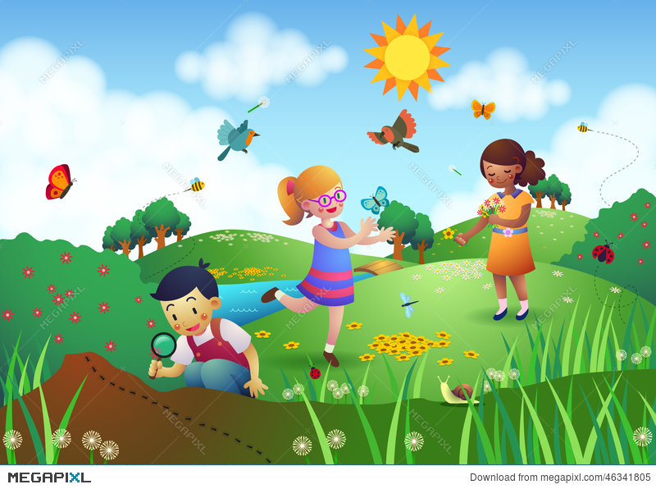

Enrichment
We will go on a village walk and then visit the seaside to comp
are the two places.
We will welcome our significant males in for a morning session.
We will take part in a bee workshop.
We will welcome our families in for a picnic as part of ‘We are the Champions’ week.
Personal, Social and Emotional Development
In our Heartsmart lessons we will think about why it is important to tell the truth. We will also develop our ability to persevere with challenging tasks and be encouraged to speak about how we feel about and deal with change
In RE we will explore stories and special places exploring the questions what can we learn from stories? What makes places special?

Literacy
Key Texts we will study in Drawing Club:
The Very Hungry Caterpillar - Eric Carle.
The Bad Tempered Ladybird – Eric Carle
The Tiny Seed – Eric Carle
Mr Seahorse – Eric Carle
We’re Going on a Bear Hunt - Michael Rosen
The Great Pet Sale – Mick Inkpen
Sharing a shell – Julia Donaldson
Grandma’s Beach - Rosalind Beardshaw
Jaspers Beanstalk Nick Butterworth
Omar, the Bees and Me – Helen Mortimer

