Music andComputing – Scratch
We will use Scratch to code a soundtrack using blocks, loops and nested loops. We will decompose programs into smaller parts and remix existing code into new projects. We will also identify errors and debug these.

Art and DT
Art – As artists we will look at Roman mosaics. We will also look at the mosaics of Antoni Gaudi, the toast mosaics of Maurice Bennett and the stamp mosaics of Peter Mason. We will critique our work to make improvements.
DT – We will develop our skills so that we can design and make an aqueduct.
Year 5
Term 5 & 6
What have the Romans ever done for us?
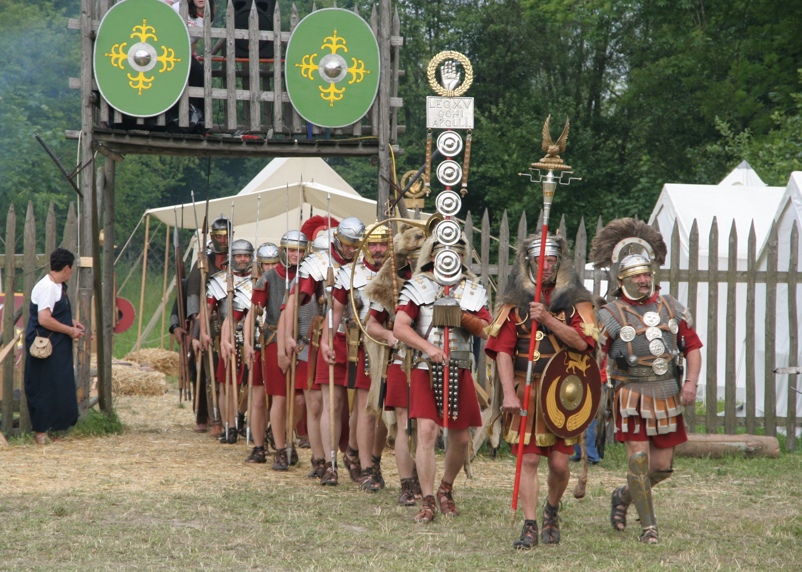

History
As historians we will study the beginnings and change of the Roman Empire and its impact on Britain including Julius Caesar’s attempted invasion in 55-54BC, the Roman Empire by AD42 and the power of its army.

Geography
As geographers we will describe and understand key aspects of physical geography, including: climate zones, biomes and vegetation belts as well as exploring countries that the Romans invaded and conquered. We will recap our knowledge on oceans whilst studying water. We will explore the differences between salt and fresh water and link with our history topic the importance water for trade and settlement.

PE – Athletics/Games/OAA
In athletics we will begin to build a variety of running techniques. We will perform a running jump with more than one component. We will improve our accuracy and confidence in throwing and catching activities. We will learn to use equipment safely and with good control. We will improve the skills, actions and ideas we need to play rounders. We will use these skills with co-ordination, control and fluency in matches. We will work together as a group to follow a map and apply problem-solving strategies to our outdoor & adventurous activities.

Enrichment
Enterprise week
Roman day in school
We are champions sport week

RE – Sikhism & Christianity
Theme: Prayer & worship. Beliefs & Practices
Key Questions: What is the best way for a Sikh and a Christian to show commitment to God?

PHSE
We will learn how to identify who and what we can trust. We will learn about the risks associated with alcohol. We will think about the successes we achieve and learn about puberty.

Modern Language- Spanish
We will recap basic phrases and learn phrases linked to the subject of home.
Science –Properties and changes of materials &Animals, including humans
As scientists we will:
- know that some materials will dissolve in liquid to form a solution, and describe how to recover a substance from a solution
- use knowledge of solids, liquids and gases to decide how mixtures might be separated, including through filtering, sieving and evaporating
- demonstrate that dissolving, mixing and changes of state are reversible changes
- explain that some changes result in the formation of new materials, and that this kind of change is not usually reversible, including changes associated with burning and the action of acid on bicarbonate of soda.
- describe the changes as humans develop to old age
- describe the simple functions of the basic parts of the digestive system in humans
- identify and name the main parts of the circulatory system, and describe the functions of the heart, blood vessels and blood
- recognise the impact of diet, exercise, drugs and lifestyle on the way their bodies function
- describe the way nutrients and water are transported within animals, including humans

Literacy Key texts/ Class reader
- The Orchard book of Roman Myths

