PE – Athletics/ Tennis
As athletes we will begin to understand the need to run at different speeds appropriate for the distance e.g. sprinting and cross country. We will learn to perform a running jump with some accuracy. We will develop our skills to perform a variety of throws using a selection of equipment, using the equipment safely and with good control.
In games we will develop our understanding of the tactics and composition when playing the games. We will continue to further develop our ball skills increasing the accuracy, coordination and control.

Year 3
Term 5 and 6
Does it always rain in the forest?
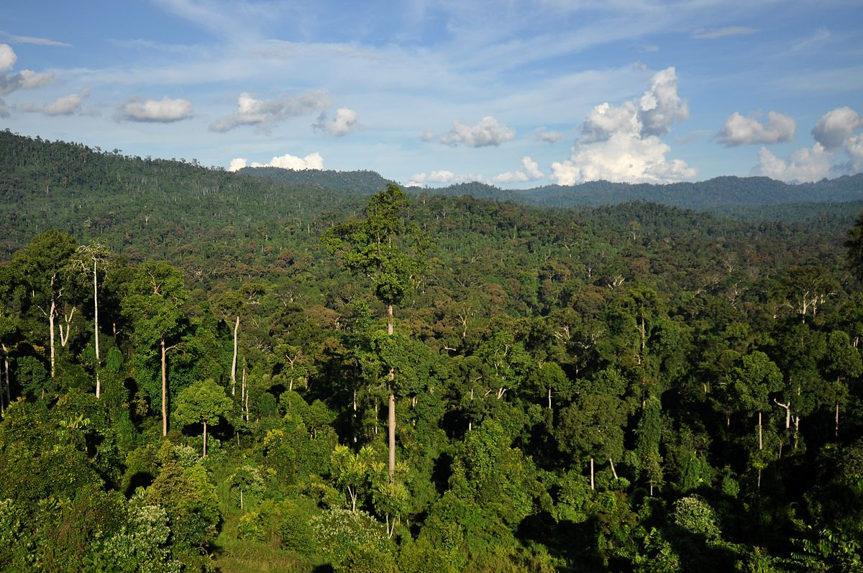

Art and DT
Art – We will look at the work of Beatriz Millhazes (painting, printing & collage) and take inspiration from her ‘Spring Love’ piece to create our own collages using tissue paper. We will also explore Henri Rousseau. We will develop our painting skills and use these skills to create our own piece inspired by Rousseau’s work.
DT – We will develop our food technology skills using ingredients and recipes from South America. We will investigate the inventor Ruth Graves Wakefield, best known as the inventor of the Toll House Cookie, the first chocolate chip cookie. We will develop our own cookie recipes and market our product.

Music
As musicians we will listen to and explore South American (Latin American) music & the instruments used. We will explore the way sounds can be combined and used expressively, beginning to recognise and identify the instruments being played. We will learn the difference between pulse and rhythm, identify the beat in music and recognise changes in timbre, dynamics and pitch. We will learn to recognise how musical elements can be used together to compose music. We will develop our understanding of the different purposes of music throughout history and in other cultures and the fact that sense of occasion affects the performance. We will use this understanding to compose our own pieces.

Science – Plants / Animals, including humans
As scientists we will:
- identify and describe the functions of different parts of flowering plants: roots, stem/trunk, leaves and flowers
- explore the requirements of plants for life and growth (air, light, water, nutrients from soil, and room to grow) and how they vary from plant to plant
- investigate the way in which water is transported within plants
- explore the part that flowers play in the life cycle of flowering plants, including pollination, seed formation and seed dispersal.
- identify that animals, including humans, need the right types and amount of nutrition, and that they cannot make their own food; they get nutrition from what they eat
- identify that humans and some other animals have skeletons and muscles for support, protection and movement.

Spanish – Fruits

Computing
Year 3 Programming (Scratch)- We will learn to use loops to program an animation, a story and a game in scratch.
RE – Hinduism
Key Questions: How can Brahman be everywhere and in everything? Would visiting the river Ganges feel special to a non-Hindu?
PHSE
We will think about ways to build strong friendships. We will think about how to deal with setbacks and change. We will learn about appropriate contact. We will learn about allergies and how to respond in an emergency.

Geography
We will explore the Amazon rainforest and learn about what life is like, the different layers, who lives there and explore the consequences of deforestation. We will look at the Amazon River. We will locate all the rainforests in the world on a map. We will learn about Brazil- recapping on continents and link with our work on rainforests. We will be able to make comparisons with where we live focusing on climate, lifestyle, human and physical geography. We will explore and answer the questions:
What is it like to live in Brazil?
How different would it be to where I live?
How much does the climate effect peoples lifestyles?

Literacy
Key texts we will study:
- The Rainforest Warrior- Anita Ganeri (Class reader)
- Hotel Flamingo- Alex Milway
- The Great Kapok Tree – Lynne Cherry
- There’s a Rang-Tan in my Bedroom

